Information Search Skills
The ability to search and find required/relevant information for your research/assignment /project is a key skill for the success of your project.
Information search skills – 4 components
Interpret your assignment – Find what information you need.
Know your Resources – Where to find the required information.
Search strategy.
Record your results.

Interpreting your assignment
Please take some time to analyze your assignment. Think about it carefully.
- What do I already know?
- How does the questions link to what I am covering in lectures?
- How much research /reading do I need to do?
- What do I need to find out about?
- What kind of information do I need? (Definitions, Statistical, Gaps, Causses & Effects)
- Where will I find this information?
- What keywords are to be used for the search?
- How will I search for these?

After brainstorming Draw a mind map
Breakdown and itemization your assignment.

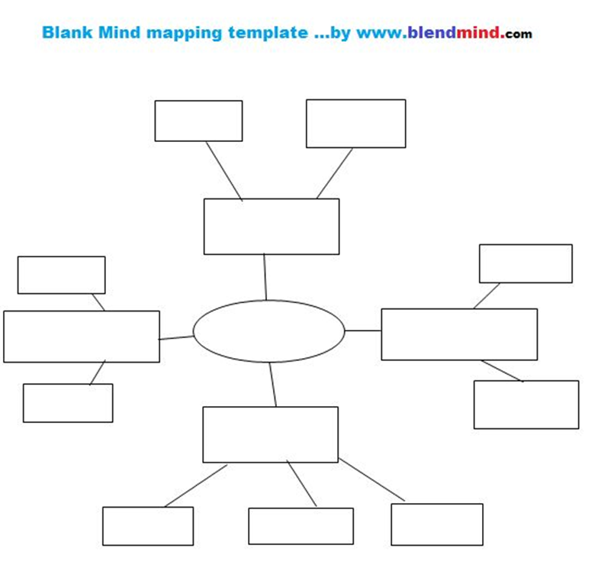

NOW
You should have an idea what information you need.

Know Where to Find Information
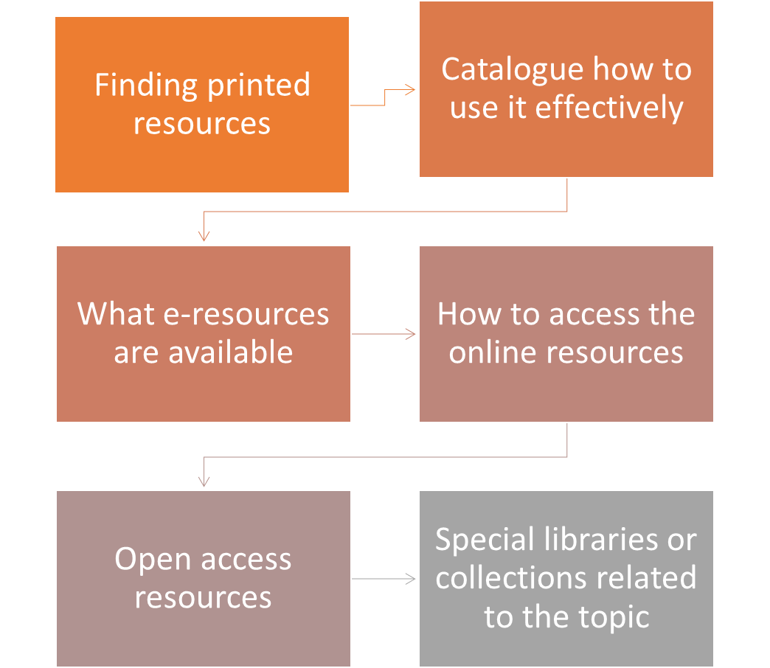

You should be able to access the below and search for books and online resources
IIT Library Portal
UOW Library
LinkedIn Learning
O’Reilly for Higher education

IT Library Portal
http://webcat.iit.ac.lk/

O’Reilly for Higher education
https://learning.oreilly.com/home/ - Search for books, videos or courses on the relevant topics
Read and bookmark information
Keep a record of the resources used

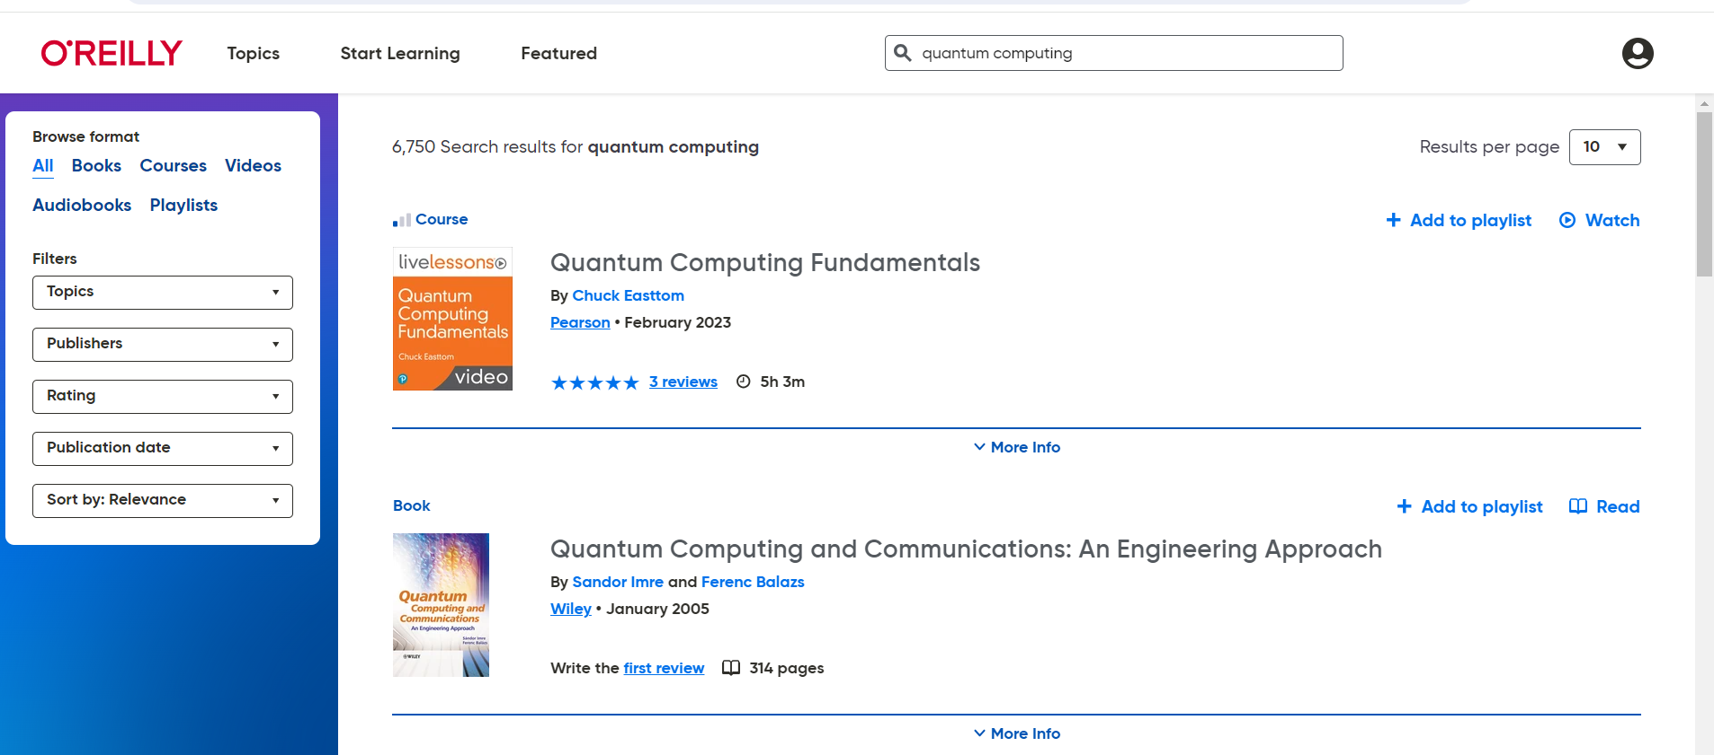

LinkedIn Learning
https://www.linkedin.com/learning

Search for courses /info on your topic

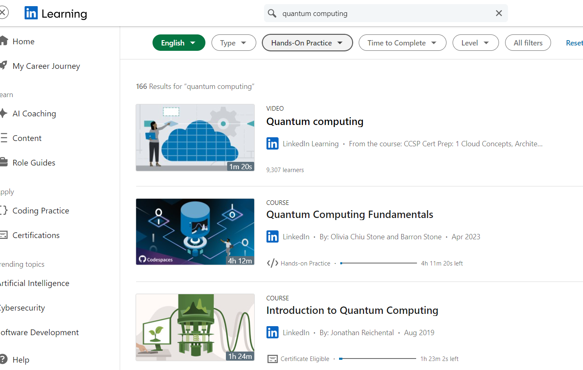

UOW Library
https://library-collections-search.westminster.ac.uk/discovery/search?vid=44WST_INST:WST_VUA

Search for info required, you can read some books online.

What Resources should I USE?

When reaching a topic for a university assignment, academic sources are preferred over other types of sources.
They have more authority and carry more weight.
Using Google for Academic Research
Google is (almost) everyone’s favourite search engine
It is a quick and easy way to search the vast amounts of free information on the Internet.
This includes government sites, many organizations and interest groups sites, open access journals, specialist blogs and much more.
The Internet is a vital source of up-to-date information.
Learn how to improve your use of Google

Google search is good starting point to search for information, specially when it’s a new topic.
If you are new to a topic, searching Google and reading Wikipedia can help you get started.
But is a reference to Wikipedia in your assignments going to impress?
Wikipedia is only as accurate as the last person who updated it.
In your academic work, you should always aim to use authoritative sources… like the encyclopaedias available via Library Search and the e-resource Credo Reference, or academic journals.

Google Scholar
Search engine for ‘scholarly information’. It searches for e-books and e-journal articles, selected reports from governments and other organisations, and references to printed books and journal articles, both free content and paid-for content.
BUT
Google Scholar focuses on what Google considers to be academic publications. But you still need to judge the quality of the information you find for yourself.

If you are using websites or blogs - evaluate before using the information.

How to Evaluate: the CRAAP Test - Evaluating Internet-Based Information - LibGuides at Bethel College Library

https://researchguides.ben.edu/source-evaluation

Some useful Links
https://fairchild-mil.libguides.com/c.php?g=1120867&p=8174273

https://fairchild-mil.libguides.com/c.php?g=1120867&p=8174275

Quantum – Google AI
https://quantumai.google/

IBM Quantum Computing
https://www.ibm.com/quantum
https://www.ibm.com/topics/quantum-computing
https://www.ibm.com/thought-leadership/institute-business-value/en-us/report/quantumsecurity
https://insights.sei.cmu.edu/blog/cybersecurity-of-quantum-computing-a-new-frontier/
https://www.scirp.org/journal/articles?searchcode=quantum+computing&searchfield=All&page=1&skid=61749086
https://www.bcs.org/events-calendar/2019/october/aimachine-learning-and-ethics-ict-ethics/

Use the key word Ethics to find info on code of practice!
Ethical issues
Code of ethics in …………

